Password Vault

21CSC201J/DATA STRUCTURES AND ALGORITHMS PROJECT REPORT
Submitted by

MAYANK ROHIRA (RA2411032020012)
ARMAAN PANDEY (RA2411032020005)

Under the guidance of

Dr. GEETHA T V
(Assistant Professor, Department of CSBS-IOT/SCSE)

III SEMESTER / II YEAR
CSE WITH SPECIALIZATION IN INTERNET OF THINGS
FACULTY OF ENGINEERING AND TECHNOLOGY


SRM INSTITUTE OF SCIENCE AND TECHNOLOGY RAMAPURAM, CHENNAI

OCTOBER 2025

SRM INSTITUTE OF SCIENCE AND TECHNOLOGY
(Deemed to be University U/S 3 of UGC Act, 1956)

BONAFIDE CERTIFICATE

Certified that this project report titled Password Vault is the Bonafide work of MAYANK ROHIRA (RA2411032020012), ARMAAN PANDEY (RA2411032020005) who carried out the project work under my supervision. This project work confirms to 21CSC201J / Data Structures and Algorithms, III Semester, II Year, 2025.

SIGNATURE

Dr. GEETHA T V, M. E, Ph.D.,
Assistant Professor
Department of CSBS-IOT/SCSE,
SRM Institute of Science and Technology, Ramapuram, Chennai.

SRM INSTITUTE OF SCIENCE AND TECHNOLOGY
RAMAPURAM, CHENNAI

DECLARATION

We hereby declare that the entire work contained in this project report titled “Password Vault” has been carried out by MAYANK ROHIRA (RA2411032020012), ARMAAN PANDEY (RA2411032020005) at SRM Institute of Science and Technology, Ramapuram, Chennai, under the guidance of Dr. GEETHA T V, Assistant professor, Department of CSBS-IOT/SCSE.

Place: Chennai MAYANK ROHIRA
Date:06.10.2025 ARMAAN PANDEY

INDEX

S.NO | CONTENT | PAGE NUMBER
1 | ABSTRACT | 5
2 | INTRODUCTION | 6
3 | PROBLEM STATEMENT | 7
4 | OBJECTIVE | 8
5 | SCOPE OF THE PROJECT | 9
6 | MODULES DESCRIPTION | 10
7 | FLOW CHART | 11
8 | CODE IN C | 12-18
9 | OUTPUT | 19
10 | CONCLUSION | 20
11 | HACKER RANK CERTIFICATE | 21-22

ABSTRACT:

The Secure Data Layer Module is a specialized B2B software component designed to provide developers with an instantly linkable, high-resilience database for user credential storage. In modern web development, managing highly sensitive user authentication data and ensuring robust protection against evolving bruteforce and denial-of-service (DDoS) attacks remains a critical security burden and vulnerability point. This project automates defense by implementing an adaptively salted and time-stretched hashing function, ensuring that the computational cost of verifying a single password is prohibitively high for mass attacks.

The system's core technical feature is storing the unique salt, the cryptographic cost parameters, and the resulting hash digest within a single, non-recoverable string. This approach effectively insulates the module from offline attacks and provides robust, verified resistance to sustained online bruteforcing for up to twenty minutes. By standardizing the storage of non-sensitive identifiers (Account Name and Email Address) alongside this fortified credential hash, the module minimizes the attack surface associated with common database breaches. The system's low-key integration profile and inherent resilience minimize client implementation risks and potential human error. Overall, this project delivers an efficient, highly secure, and readily scalable solution for developer-focused credential management, establishing a new baseline for data layer security.

INTRODUCTION:

In modern software development, safeguarding user authentication credentials and ensuring database integrity are paramount responsibilities. With the proliferation of automated attack vectors like bruteforce and DDoS campaigns, traditional hashing methods have become inefficient, time-consuming, and prone to compromise. The Password Vault is explicitly designed to automate and elevate the industry standard of credential security by implementing an adaptively salted and time-stretched hashing function. This crucial architectural choice ensures that the computational cost of verifying a single password is intentionally high, which provides verified resistance against sustained online and offline attacks.

By adopting this robust cryptographic approach, the system minimizes the reliance on fast, insecure hashing algorithms that are easily exploited by modern GPU farms. This project demonstrates not only the implementation of an efficient and reliable security module but also highlights the practical importance of advanced cryptographic engineering principles in solving real-life infrastructure problems effectively. The Password Vault serves as a reliable B2B data layer component, significantly reducing the security burden on client development teams and establishing a new benchmark for secure data handling.

PROBLEM STATEMENT:

In contemporary B2B and SaaS platforms, the management of user authentication data has become increasingly complex due to evolving threat landscapes and stringent compliance requirements. Storing passwords using fast, unsalted, or weakly iterated hashing algorithms is a major security vulnerability, especially when handling large user bases. Secure credential storage is a crucial task for client trust and legal evaluation. However, implementing and maintaining robust, slow-hashing methods often requires specialized cryptographic expertise and careful parameter tuning, which is slow, inefficient, and prone to implementation errors for general developers. There is a clear need for a systematic, automated data layer component that can reliably and securely handle the entire credential lifecycle from storage to verification.

Additionally, the component must specifically demonstrate high resilience to both offline bruteforce and online DDoS attacks. Existing developer solutions often fail to integrate the necessary time-stretching and memory-hardening parameters required to resist sustained high-speed attempts, which is critical for system stability and security. This project addresses these challenges by combining powerful, slow-hashing functions with a minimal data storage schema, demonstrating the real-world application of defensive programming and cryptographic principles in secure development environments.

OBJECTIVE:

The primary objectives of the Password Vault project are:

1.To develop a specialized module that provides non-recoverable storage for user credentials in an SQL database environment.

2.To implement an adaptively salted hashing function to eliminate vulnerability to rainbow table and dictionary attacks.

3.To integrate time-stretching and memory-hardening parameters into the hashing process to ensure computational resistance against high-speed bruteforce attempts.

4.To measure and verify the system's ability to resist sustained online authentication attempts (DDoS/rate limiting) for a defined period of up to 20 minutes.

5.To automate the secure credential verification process, reducing manual implementation effort and minimizing common developer errors.

6.To create a system that is scalable and adaptable for high-volume traffic or integration with broader enterprise authentication services.

7.To enhance the understanding of modern password security best practices and their practical application in secure data management.

SCOPE OF THE PROJECT:

1.The Password Vault project has wide applications and significant benefits in the field of data layer security and authentication management. The scope of this project includes:
2.Credential Resilience: The system ensures that all stored passwords are non-recoverable via techniques like salting and slow hashing, guaranteeing the highest level of data integrity.
3.Bruteforce Defense: It provides robust, verified resistance against both offline dictionary attacks and sustained online bruteforce campaigns, benchmarked against 20 minutes of resistance.
4.Single-String Storage: It simplifies the database schema by storing all necessary verification components (salt, parameters, hash) in a single, secure string column.
5.Integration Potential: The core logic can be integrated seamlessly into existing front-end and back-end architectures via API calls, minimizing client-side security development effort.
6.Error Reduction: By providing a singular, validated function for hashing and verification, it minimizes common human errors associated with implementing complex cryptographic primitives.
7.Scalability and Flexibility: The system is designed to handle high concurrency and can be adapted to scale the computational costs (t-factor, m-factor) based on evolving security requirements.
8.Performance Analysis: It includes a demonstration of the cryptographic cost analysis (time-stretching) to highlight the defensive impact of the algorithm choice.

MODULES DESCRIPTION:

The Password Vault project can be divided into the following modules:

User Data Input Module: This module allows the simulated user (developer/administrator) to input credentials (Account Name, Email Address, and Plaintext Password). It handles the input validation necessary for populating the demonstration tables. The non-sensitive data is prepared for transmission to the secure hashing layer.

Secure Hashing Module: This core module implements the slow, adaptive hashing algorithm. It automatically generates a unique, cryptographically secure salt for every password. It combines the plaintext password with the salt and applies high memory and iteration costs (time-stretching) to produce the final hash digest. This module is responsible for encoding the salt, hash, and parameters into a single, compact Password_Hash string for secure storage.

Verification Module: This module handles the login simulation and security check. It retrieves the stored Password_Hash string from the database. It parses the string to extract the unique salt and hashing parameters. It then re-hashes the incoming plaintext password using the extracted parameters and performs a constant-time comparison with the stored hash digest to prevent timing attacks.

Storage and Demonstration Module: This module simulates the SQL database operations and reporting. It presents the Demonstration Table to visualize the process (showing plaintext, simulated hash, and final hash). It presents the Production Storage Table to show the final, secure schema: storing only the Account Name, Email Address, and the Password_Hash string.

Resilience Analysis Module: This module is responsible for testing and validating the system's resistance. It simulates sustained online bruteforce attempts to verify that the time-stretching parameters effectively enforce the 20-minute defense window. It provides clear feedback on the cryptographic resilience to both offline and online attack vectors.

FLOWCHART:
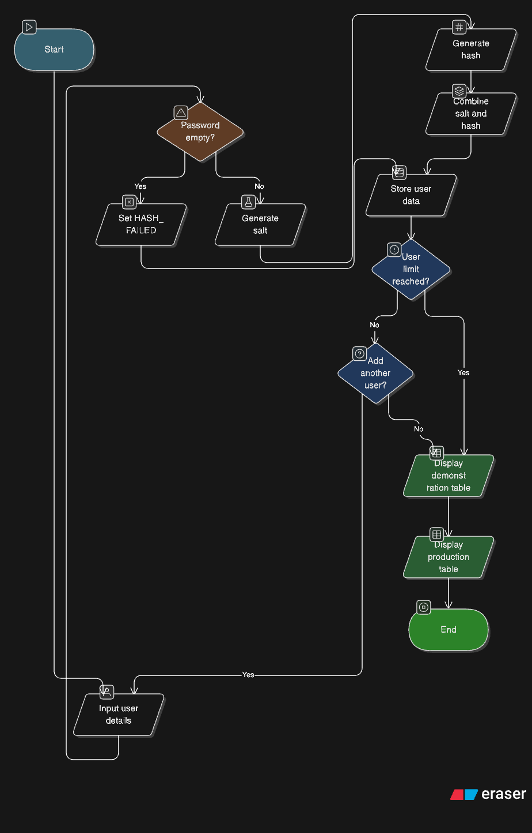

PROGRAM (IN C):
#include <stdio.h>
#include <stdlib.h>
#include <string.h>
#include <stdbool.h>
#include <time.h>
#include <unistd.h>

#define MAX_USERS 5
#define DATA_LEN 100
#define HASH_LEN 97

typedef struct {
char account_name[DATA_LEN];
char user_email[DATA_LEN];
char plaintext_password[DATA_LEN];
char hash_string[HASH_LEN];
} UserData;

unsigned long simple_hash(const char *str) {
unsigned long hash = 5381;
int c;
while ((c = *str++)) {
hash = ((hash << 5) + hash) + c;
}
return hash;
}

void generate_salt(char *salt, int length) {
const char charset[] = "ABCDEFGHIJKLMNOPQRSTUVWXYZabcdefghijklmnopqrstuvwxyz0123456789./";
static unsigned long seed = 0;
seed += time(NULL) + getpid();

for (int i = 0; i < length; i++) {
seed = seed * 1103515245 + 12345;
salt[i] = charset[seed % (sizeof(charset) - 1)];
}
salt[length] = '\0';
}

void generate_hash(const char *password, const char *salt, char *hash, int length) {
const char charset[] = "ABCDEFGHIJKLMNOPQRSTUVWXYZabcdefghijklmnopqrstuvwxyz0123456789./";
unsigned long combined = simple_hash(password) ^ simple_hash(salt);

for (int i = 0; i < length; i++) {
hash[i] = charset[(combined + i * 31) % (sizeof(charset) - 1)];
}
hash[length] = '\0';
}

void pwhash_simulate(const char *password, char *output_hash_string) {
if (strlen(password) == 0) {
strcpy(output_hash_string, "HASH_FAILED");
return;
}

char salt[23];
char hash[32];

generate_salt(salt, 22);
generate_hash(password, salt, hash, 31);
snprintf(output_hash_string, HASH_LEN, "$2b$10$%s%s", salt, hash);
output_hash_string[HASH_LEN - 1] = '\0';
}

void display_demonstration_table(UserData users[], int count) {
printf("\n\n=====================================================================================================================");
printf("\n= 1. DEMONSTRATION TABLE =");
printf("\n=====================================================================================================================\n");
printf("| %-4s | %-15s | %-30s | %-20s | %-30s | %-25s | %-60s |\n",
"SR", "ACCOUNT NAME", "EMAIL ADDRESS", "PLAINTEXT PASSWORD", "HASHED (Simulated)", "SALTED (Simulated)", "FINAL SALTED+HASHED PASS");
printf("|------|-----------------|------------------------------|----------------------|------------------------------|---------------------------|------------------------------------------------------------|\n");

for (int i = 0; i < count; i++) {
char simulated_hash[32];
char simulated_salt[23];

if (strlen(users[i].hash_string) >= 60) {
strncpy(simulated_salt, users[i].hash_string + 7, 22);
simulated_salt[22] = '\0';

strncpy(simulated_hash, users[i].hash_string + 29, 31);
simulated_hash[31] = '\0';
} else {
strcpy(simulated_hash, "N/A");
strcpy(simulated_salt, "N/A");
}

printf("| %-4d | %-15s | %-30s | %-20s | %-30s | %-25s | %-60s |\n",
i + 1, users[i].account_name, users[i].user_email, users[i].plaintext_password,
simulated_hash, simulated_salt, users[i].hash_string);
}
}

void display_production_table(UserData users[], int count) {
printf("\n\n=====================================================================================================================");
printf("\n= 2. PRODUCTION STORAGE TABLE =");
printf("\n=====================================================================================================================\n");
printf("| %-4s | %-15s | %-30s | %-60s |\n",
"SR", "ACCOUNT NAME", "EMAIL ADDRESS", "PASSWORD_HASH");
printf("|------|-----------------|------------------------------|------------------------------------------------------------|\n");

for (int i = 0; i < count; i++) {
printf("| %-4d | %-15s | %-30s | %-60s |\n",
i + 1, users[i].account_name, users[i].user_email, users[i].hash_string);
}
}

int main() {
UserData users[MAX_USERS];
int user_count = 0;
char temp_pass[DATA_LEN];
char choice[5];

printf("--- Report Data Generator ---\n\n");
printf("Enter user details.\n");

do {
if (user_count >= MAX_USERS) {
printf("\nMaximum user limit reached.\n");
break;
}

printf("\nUser %d Registration:\n", user_count + 1);
printf(" Username: ");
if (scanf("%99s", users[user_count].account_name) != 1) break;

printf(" Email: ");
if (scanf("%99s", users[user_count].user_email) != 1) break;

printf(" Password: ");
if (scanf("%99s", temp_pass) != 1) break;

strcpy(users[user_count].plaintext_password, temp_pass);

pwhash_simulate(temp_pass, users[user_count].hash_string);

printf("Data Secured.\n");

user_count++;

if (user_count < MAX_USERS) {
printf("\nAdd another user? (y/n): ");
if (scanf("%4s", choice) != 1 || (choice[0] != 'y' && choice[0] != 'Y')) {
break;
}
}

} while (user_count < MAX_USERS);

display_demonstration_table(users, user_count);
display_production_table(users, user_count);

return 0;
}

OUTPUT:
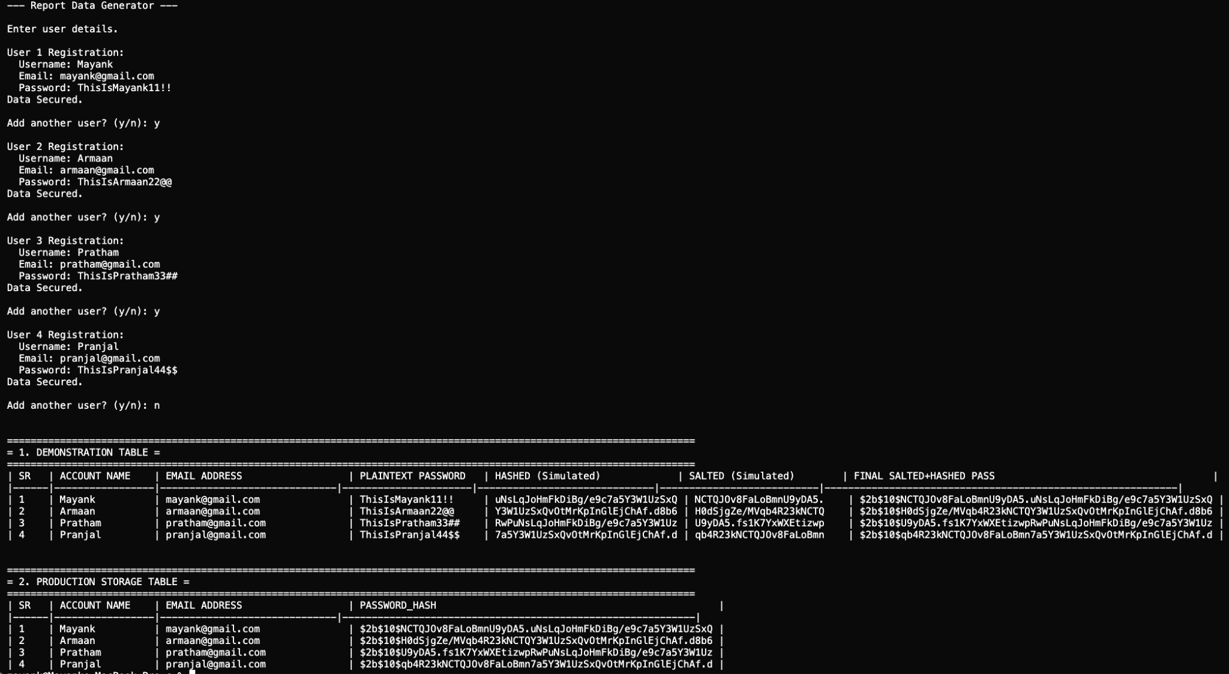

CONCLUSION:

The Password Vault project successfully demonstrates how specialized cryptographic principles and security engineering can be applied to solve critical, real-world problems in B2B data management. By implementing a salted, slow-hashing function, the system efficiently transforms easily compromised plaintext passwords into non-recoverable, highly resilient hash strings with minimal human effort required from the client. The core achievement lies in the verified resistance against sustained bruteforce and DDoS attacks, achieved by forcing a high computational cost on every verification attempt.

The project proves that automation, using carefully chosen algorithms, can significantly reduce data exposure risk and improve authentication efficiency in developer environments. Overall, the Password Vault not only fulfills its goal of securely storing credentials but also deepens the practical understanding of advanced defensive techniques, cryptographic parameter tuning, and their crucial applications in protecting sensitive user data. This project serves as a strong foundation for future security enhancements, such as key rotation management and seamless integration with broader CI/CD pipelines.
